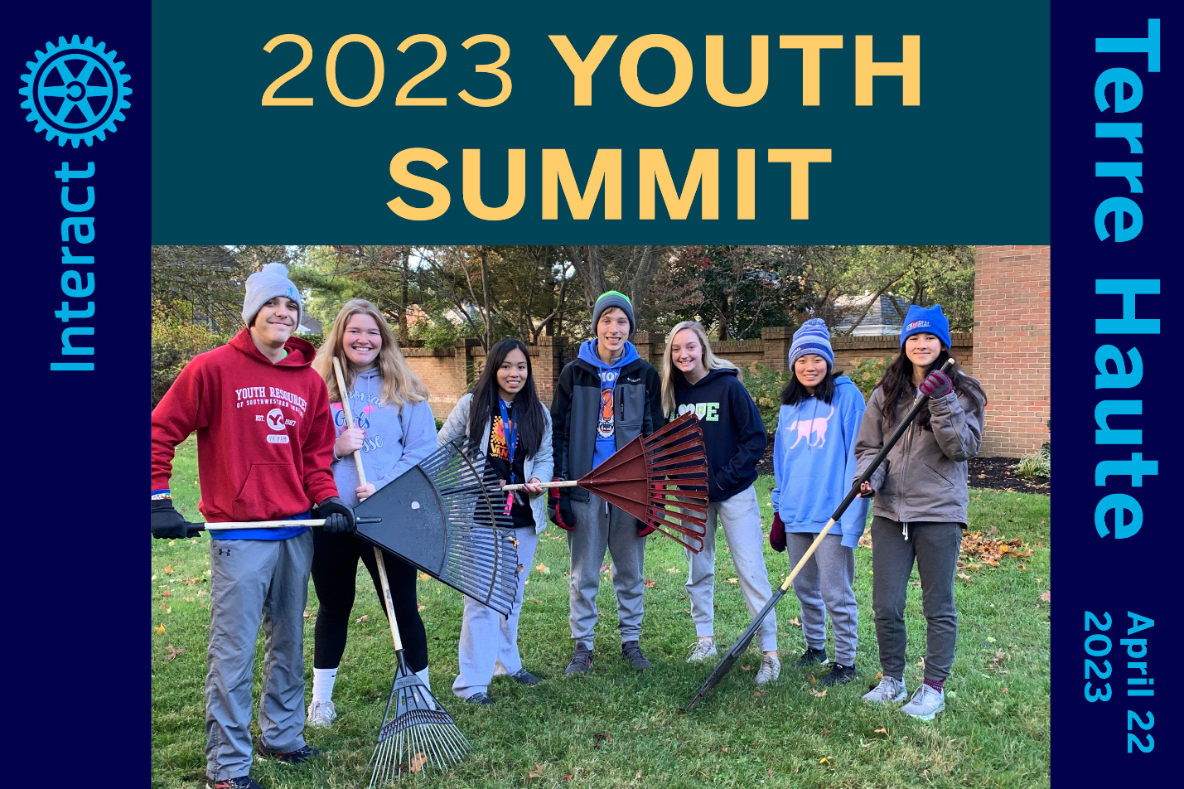
CALLING ALL INTERACT MEMBERS AND RYLA PARTICIPANTS!
Join us for the Inaugural …
ROTARY YOUTH SUMMIT!
Saturday, April 22, 2023 | 9:00am-5:00pm
Terre Haute Convention Center

A PROGRAM TAILORED FOR YOU
Enjoy Dynamic National Speakers | Participate in a Service Project
Network with New Friends | Brainstorm Great Ideas for Your Clubs
Enhance your Leadership Skills

YOUR SPONSOR ROTARY CLUB COVERS COST
Breakfast and Lunch Included

INTERESTED TO PARTICIPATE?
>> REGISTER HERE <<

2023 YOUTH SUMMIT INFO
FOR SPONSORING CLUBS, STUDENTS, AND PARENTS

STUDENT PARTICIPANTS and PARENTS/GUARDIANS

- Fill out the Online Application, no later than April 3
- Contact your Interact Club sponsor or Rotary Club/RYLA contact to confirm support

SPONSORING ROTARY CLUBS

- Participating student’s fee: $40 per student
- Send a check made out to “District 6580” to
District 6580 Treasurer Matt Lindsey
P.O. Box 1355
Vincennes, IN 47591
Please include the name of the student(s) you’re sponsoring.

QUESTIONS?

- If you have any questions or comments, please send an email to

Janie Whaley, Interact District Coordinator
janie.whaley@twc.com
Joy Khan Harter, Assistant Governor/Youth Summit Committee
joytracy9@gmail.com

